Logging into Office365
Table of contents
Logging in 1
Application desktop 4

Logging in

Go to https://www.office.com/ to log into your account.

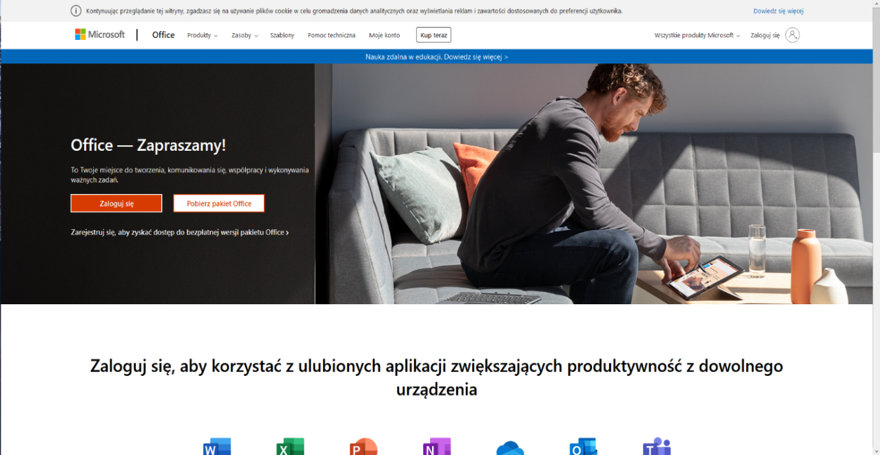

Click on „Log in” [„Zaloguj się”]. The login window will be displayed. Type your WSB University email address: name.surname@student.wsb.edu.pl [imie.nazwisko@student.wsb.edu.pl]. Do not use any diacritical marks in your name and surname (like ą,ę,ó).

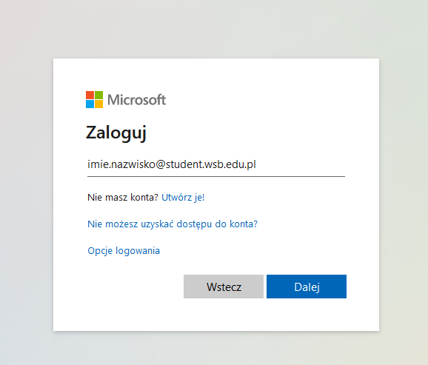

Then click on „Next” [„Dalej”]. When you log in for the first time, you will be asked to change the password.
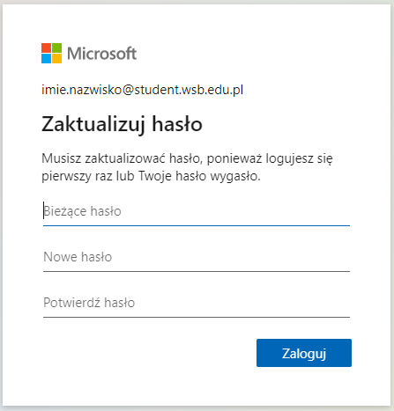

After logging in, you will be asked to choose the account recovery method. You have to choose one option.

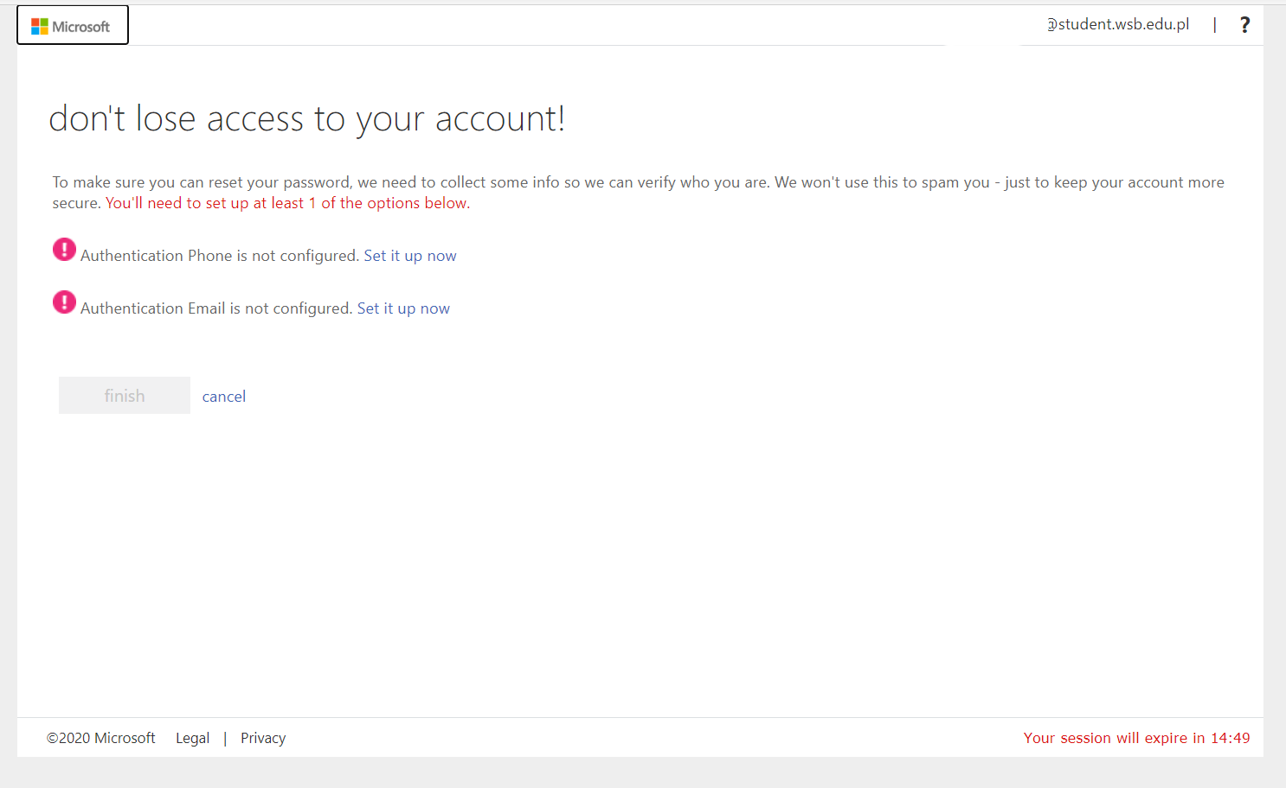

You may choose between two methods of authentication: by phone or additional email address. After you provide the phone number or email address, Microsoft will send you a verification code (via text message or email, depending on the method selected). Type in the code received and click on “Verify” [“Weryfikuj”].

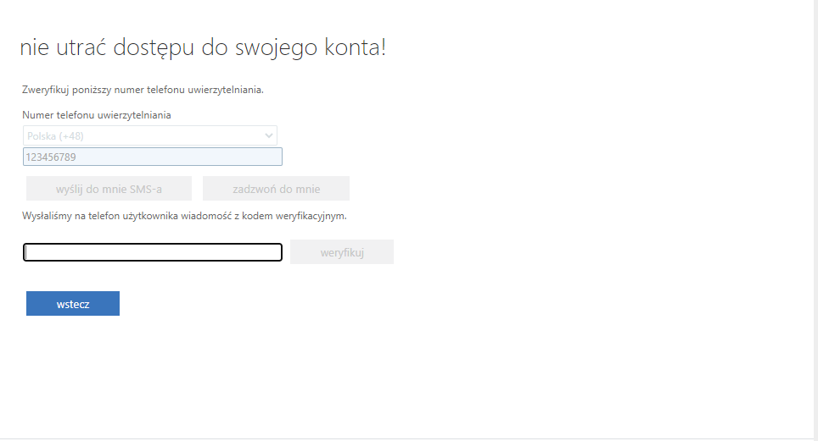
When the code is verified, the system logs the user in. Your email address or phone number will be used in case you need to reset the password to Office365.

Application desktop
After logging in you will see the whole desktop of Office 365 (see picture below).
On the left you will find the application menu.
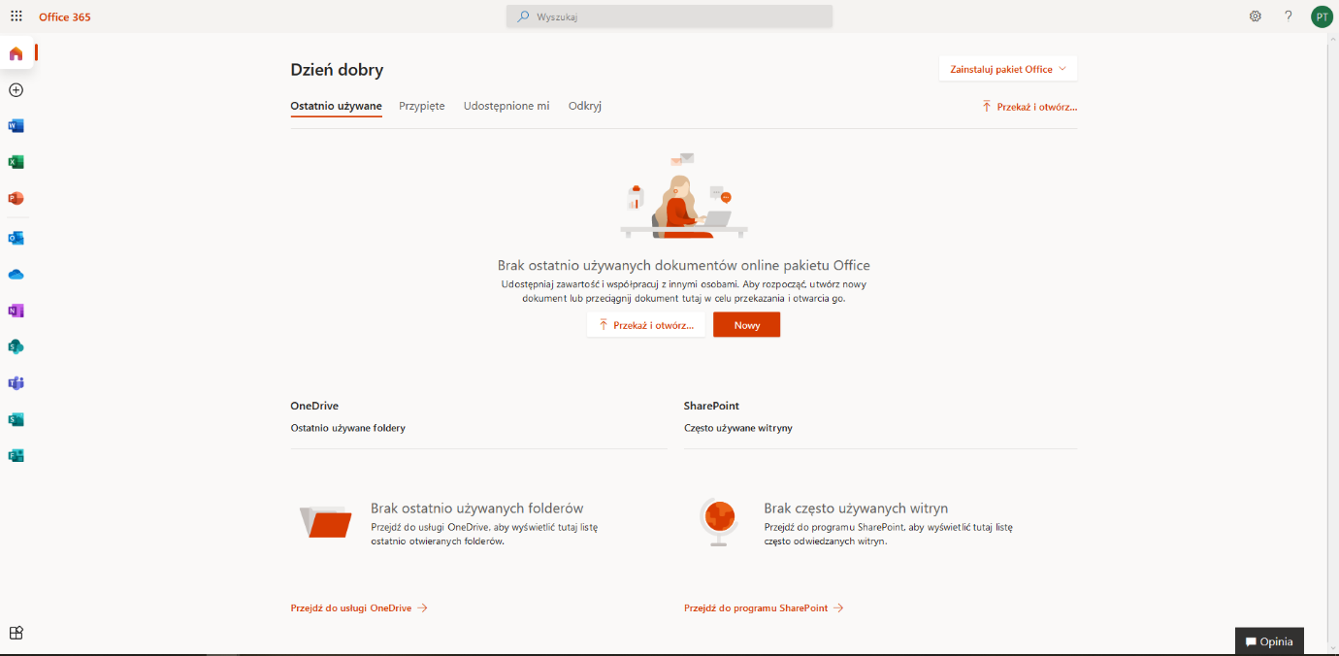

When you click on the button in the left bottom corner, all the applications are presented.

